TEACHER:MWALE CHI
KENNETH KAUNDA SECONDARY SCHOOL DESIGN AND TECHNOLOGY DEPARTMENT
LESSON PLAN

SUBJECT: DESIGN AND TECHNOLOGY CLASS:…… … DATE:……/……./20…. DURATION:………….
BOYS:…………………… GIRLS ………………………………………. TOTAL OF PUPILS… TOPIC: TRIANGLES SUBTOPIC: TRIANGLES
LEARNING OUTCOMES LSBAT
- Define triangle
- Identify types of triangles
- Draw and label the Parts of a triangle
RATIONALE
Knowledge: Construction of (equilateral, isosceles, acute, abuse and right angled) Angles and perimeter.
Skills; Accurate construction of triangles
Values: Awareness of methods of constructing triangle
TEACHING AIDS
……………………………………………………………………………………………………………………………………………

PART | LESSON CONTENT | METHODOLO GY | LEARNER ACTIVITY
introduction | - Recap on the previous lesson | Questions and answers | Provide answers
Developme nt | TRIANGLES  - The triangle is a plane figure bounded by three straight sides.  PARTS OF A TRIANGLE  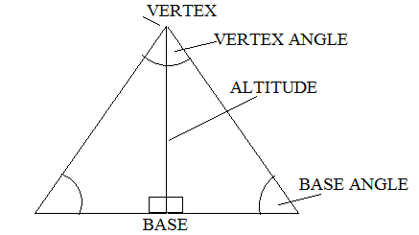  TYPES OF TRIANGLES  - A scalene triangle  - All the three sides are unequal and  - All three angles are unequal  - An isosceles triangle  - Two sides and two angles are equal.  - An equilateral triangle  - All the sides and all the angles are equal.  - A right-angled triangle  - Triangle containing one right angle. | Questions And Answers  Demonstration  V/E | Taking note of important points  Provide answers
Application | CLASS EXERCISE  - Define triangle.  - Draw and label the parts of the triangle  - State 4 types of triangles and explain their characteristic. | Questions And Answers | Provide answers
Conclusion | - Recap on the main steps and points | V/E
LESSON EVALUATION

